

# Experiment No.: 09

**Aim:** Write an application that draws basic graphical primitives on the screen.

# Theory:

A graphical application that draws basic primitives is designed to visually represent fundamental geometric shapes such as lines, rectangles, circles, and polygons on a digital canvas. This process begins with initializing a graphics environment using a suitable library, such as Pygame in Python, Java AWT/Graphics2D, OpenGL, or DirectX, depending on the platform and programming language. The application sets up a drawing canvas, defining its dimensions, background color, and rendering settings. Each shape is drawn using predefined functions, where parameters like position, size, color, and thickness are specified to control the appearance of the primitives.

The rendering process typically occurs within a continuous loop that updates the display at regular intervals, ensuring smooth visualization. This loop also listens for user events like mouse clicks, key presses, or touch gestures, allowing for interactive modifications such as moving, resizing, or changing the colors of shapes. The drawing of primitives follows specific algorithms; for example, lines are rendered using the Bresenham algorithm, circles with the Midpoint Circle Algorithm, and complex polygons using triangulation techniques for efficient rendering.

Modern implementations may enhance the graphical output by integrating antialiasing techniques to smooth edges, layering methods for handling overlapping elements, and transformations such as scaling, rotation, and translation to modify shapes dynamically. Additionally, graphical applications can store shape data in memory, allowing users to edit, save, or reload previous drawings. Beyond basic primitives, these applications serve as the foundation for more advanced developments in computer graphics, UI/UX design, animations, simulations, and game development, demonstrating the fundamental role of graphical primitives in digital visualization.

Github Link: [https://github.com/mitalitangadi2003/mitali-Mobile-Computing-Experiments/tree/c4132968bcfee5e40916dfc14269c802692f99af/EXP09-Graphical%20Primitives](https://github.com/Sanketkalsait21/sanketkalsait-Mobile-Computing-Experiments/tree/c4132968bcfee5e40916dfc14269c802692f99af/EXP09-Graphical%20Primitives)



# Screenshot of Output :

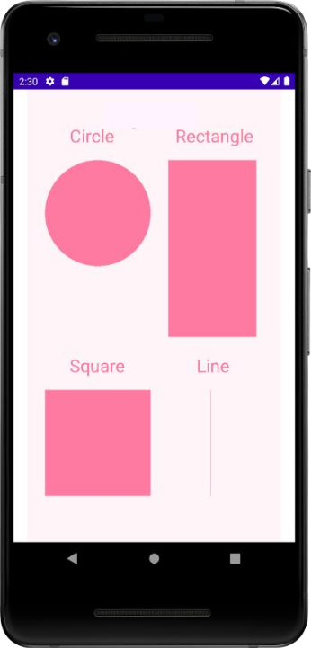

**Conclusion:** Thus we implemented an application that draws basic graphical primitives on the screen.